Abstract

This report deals into the fascinating realm of business expenses and provides a visual exploration of the various expenditures incurred by different businesses

ESTIMATION OF BUSINESS EXPENSES

A DETAILED REPORT USING TABLEAU

1. **INTRODUCTION** 
   1. Overview

This report deals into the fascinating realm of business expenses and provides a visual exploration of the various expenditures incurred by different businesses. It showcases the distribution of expenses, identifies key cost drivers, and highlights areas of potential optimization or concern.

* 1. Purpose

 To Extract the Insights from the data and put the data in the form of visualizations, Dashboards and Story we employed Tableau tool. Decision-makers, financial analysts, and stakeholders can gain valuable insights into the financial health of businesses, identify areas of inefficiency or opportunity, and make informed decisions to optimize resources and drive growth.

1. **PROBLEM DEFINITION & DESIGN THINKING**
   1. Empathy Map

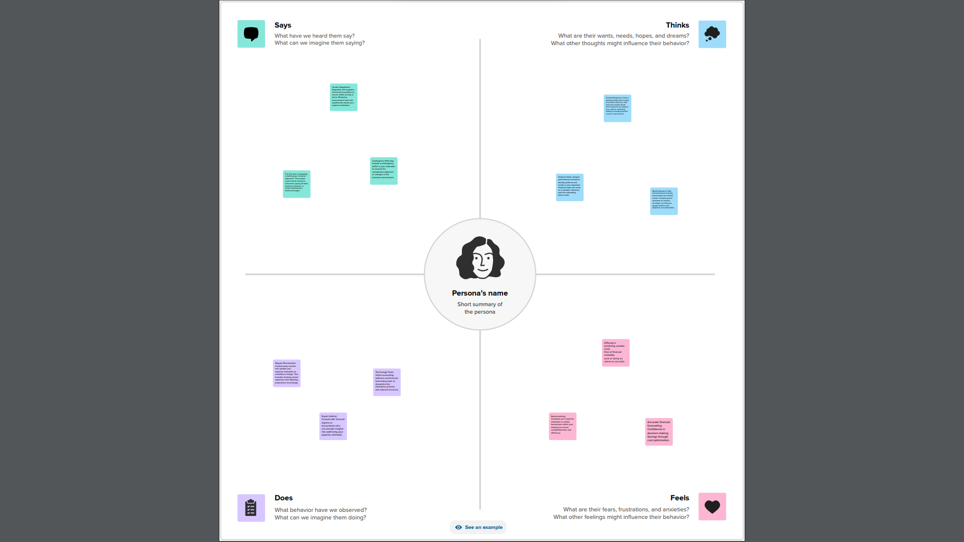

* 1. Ideation & Brainstorming Map

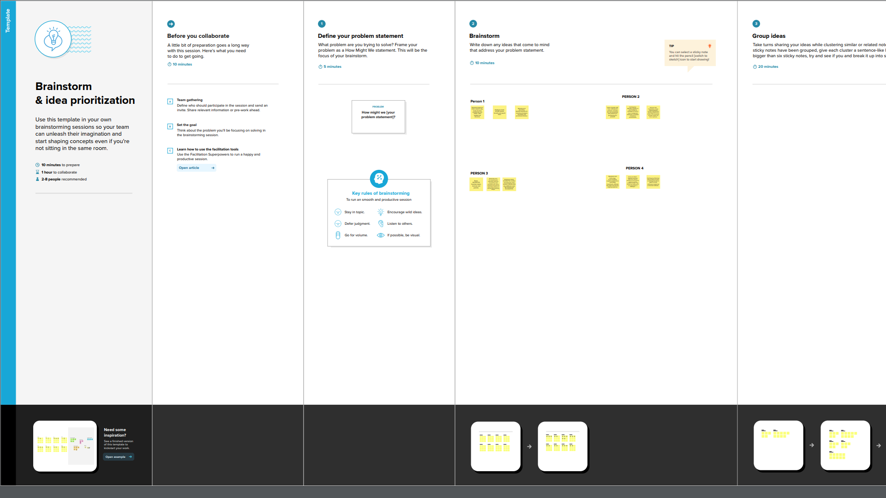

1. **RESULT**

Data Visualisation:

# Data visualization is the process of creating graphical representations of data to help people understand and explore the information. The goal of data visualization is to make complex data sets more accessible, intuitive, and easier to interpret. By using visual elements such as charts, graphs, and maps, data visualizations can help people quickly identify patterns, trends, and outliers in the data. The visual representations allow for intuitive analysis, facilitating a deeper understanding of expenditure patterns and their implications for business performance.

# Dash board:

# A dashboard is a graphical user interface (GUI) that displays information and data in an organized, easy-to-read format. Dashboards are often used to provide real-time monitoring and analysis of data and are typically designed for a specific purpose or use case.

# Story:

# A data story is a way of presenting data and analysis in a narrative format, intending to make the information more engaging and easier to understand.

# DASHBOARD

# Expense Breakdown: Insights into Diverse Business Costs

# 

# 

# Business Expenditure Overview

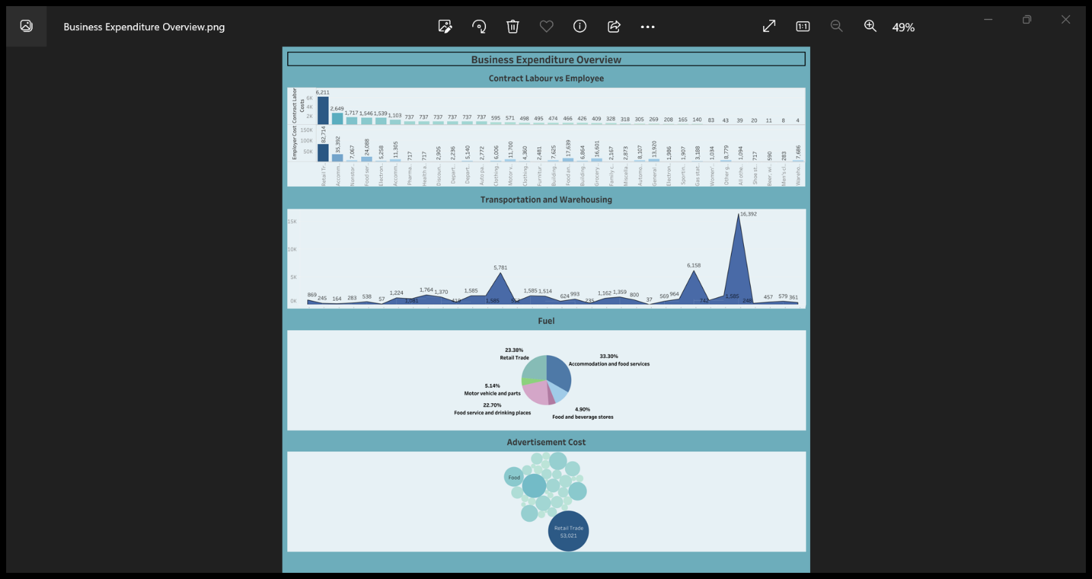

# Expense Insights

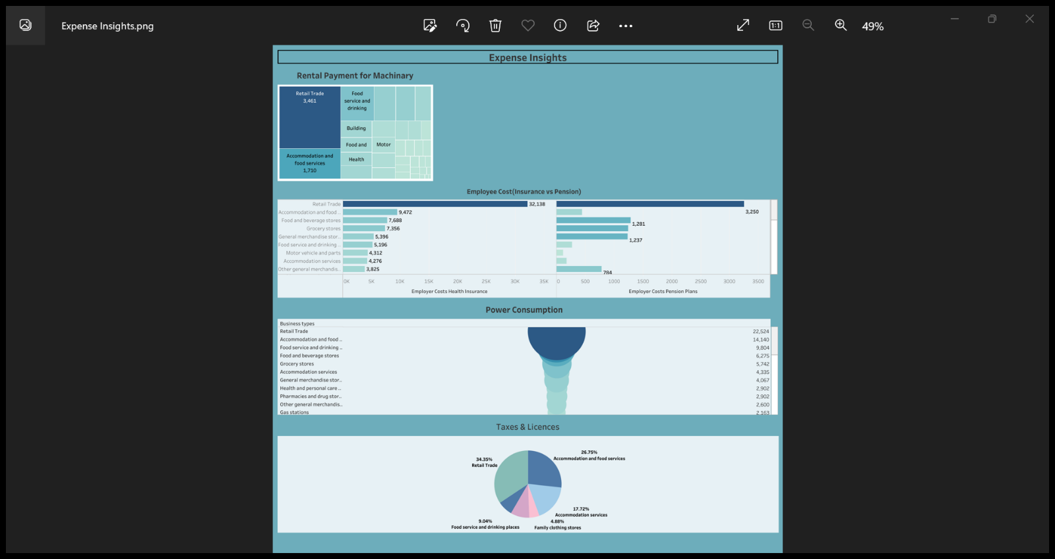

**STORY**

# Expenses 1

# Expenses 1.png ‎- Photos

# Expenses 2

# Expenses 2.png ‎- Photos

1. **ADVANTAGES & DISADVANTAGES**

Advantages:

* + - The analysis of business expenses and financial management contributes to economic stability by optimizing costs and fostering long-term sustainability.
    - It allows for better resource allocation, enabling businesses to invest in innovation and community engagement.
    - By understanding and managing expenses, companies can drive growth, maintain a strong financial position, and make strategic business decisions with confidence.

Disadvantages:

* + The solution derived from the analysis may not always be the best possible solution.
  + The data need to be carefully correlated and compared to derive a useful analysis, failing which would result in a misleading and deceptive analysis of the data.
  + Some costs may not be immediately apparent or may be hidden during the estimation process. These hidden costs can surface later, leading to budget overruns.

1. **APPLICATIONS**

* **Budgeting** – To make comprehensive financial plans that outline expected costs and revenue.
* **Financial Reporting** - Essential for assessing the financial health and performance of a business.
* **Tax Planning** – Helps in tax planning as many expenses incurred during business operations are tax-deductible.
* **Profitability Analysis** - Helps in assessing profitability, and making strategic decisions to enhance overall financial performance.
* **Decision Making** - Business leaders use expense data to make informed decisions about resource allocation, investment, pricing strategies, and overall business strategy.

1. **Conclusion**

* The operating expenses is the highest for **retail trade** and the least for **men’s clothing stores.**
* The major portion of the operating expenses is contributed by the annual payroll of employees.
* All the business employers spend considerable amount of money on the insurance of the employees compared to pensions.
* Costs of maintenance of building is the highest for **retail trade** and the least for **auto parts and tire stores.**
* The expenses yoy (year-over-year) of **clothing stores** is seen to have increased from 2006 to 2007, then decreased gradually for 2 consecutive years i.e., 2008 and 2009 and from 2009 on it is seen to have significant increase till 2011.
* Among all the businesses **accommodation and food service** spends the highest sum of amount on fuel.
* Among all the businesses, **beer, wine, and liquor stores** has the least advertisement cost.

1. **Future Scope**

* **Natural Language Processing** - Integrating natural language processing capabilities into expense analytics tools can enhance the ability to analyze and understand unstructured data, such as text from invoices, receipts, and expense reports.
* **Advanced Visualisation Techniques -** Future improvements in data analytics could involve the use of advanced visualization techniques, such as augmented reality (AR) or virtual reality (VR), to represent expense data in more immersive and interactive ways.
* **Blockchain -** Implementing blockchain technology can enhance the transparency and traceability of financial transactions.
* **Enhanced Security Measures -** Expense analytics should include enhanced cybersecurity measures. This may involve the use of advanced encryption, biometric authentication, and other security technologies to protect financial data.
* **Cloud – Based Solutions -** Increased reliance on cloud-based solutions can enhance accessibility, scalability, and collaboration in expense analytics.